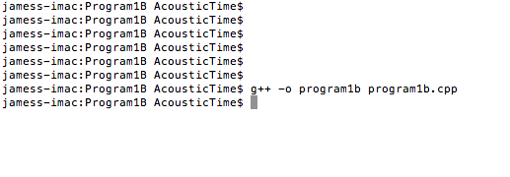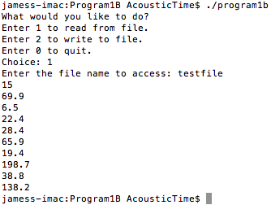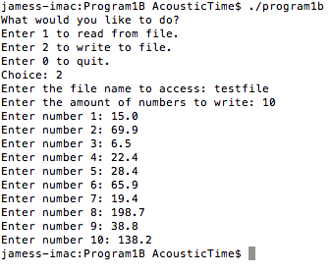 **Compilation Image**

**Write Image Read Image**

**Design Methodology Diagram**

**Main Function**

call menu() function

call filename() function

call read() or write() function based on menu choice

**Menu Function**

display menu, return choice

**FileName Function**

ask user for file name, return choice

**read Function**

read selected file and display numbers

**write Function**

ask user for amount of numbers

allow user to enter numbers and output to file